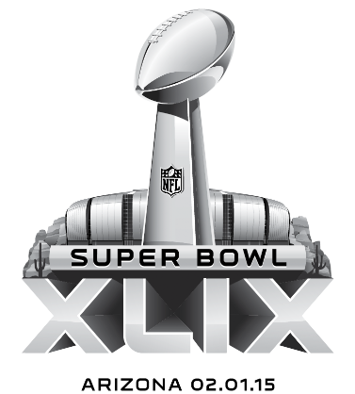
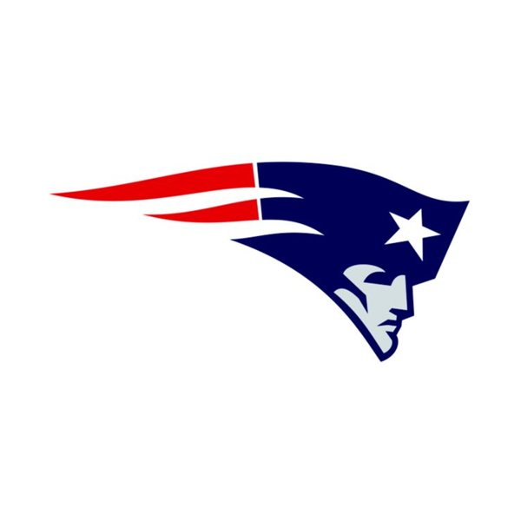
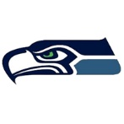
Beer Specials
Hightower Harpoon, Richard Red Hook Sherman
$4.50

Super Bowl Specials
New England Chowder Collins cup 3.50/Brady bowl 4.95
Seattle Super Hot Dog $3.50 per dog
Grilled Hot Dog with cream cheese and grilled onions – An iconic Seattle snack

$5 Menu
Wild Wilson Nachos
Gronk Grinder with sausage
6 Jumbo Wilfork Wings
Marshawn Lynch Mozzarella Sticks

